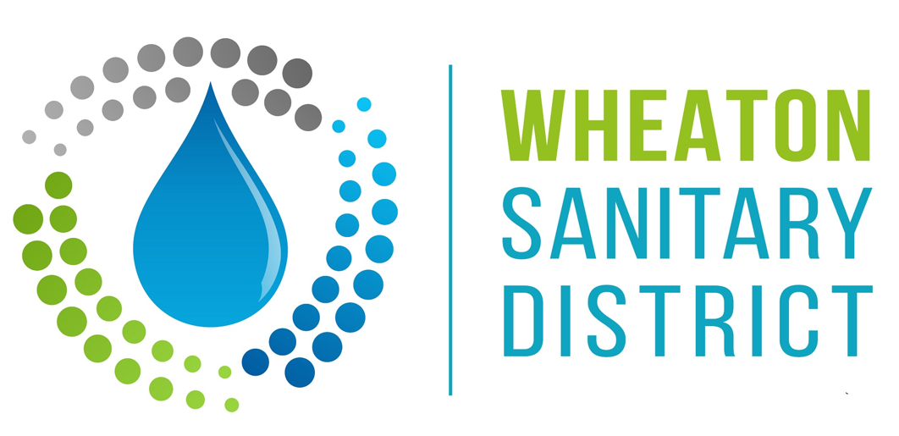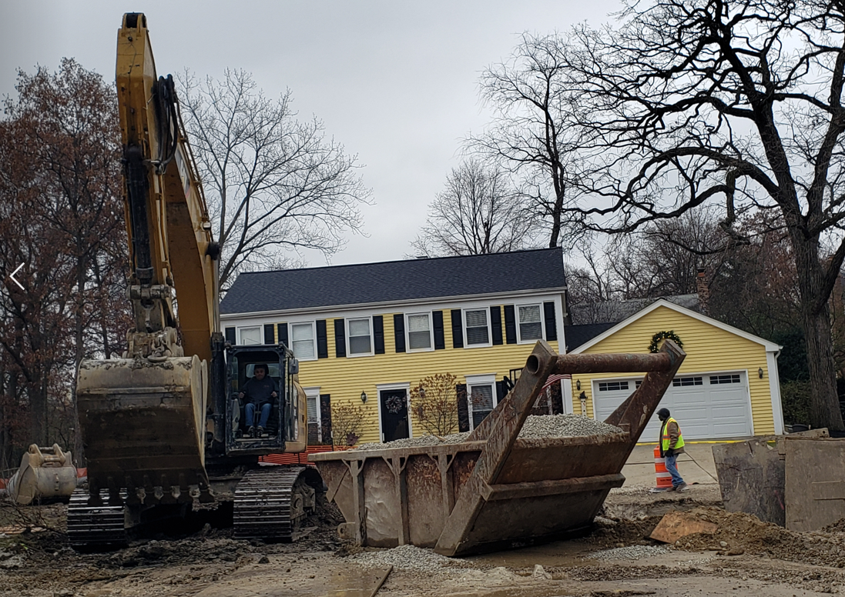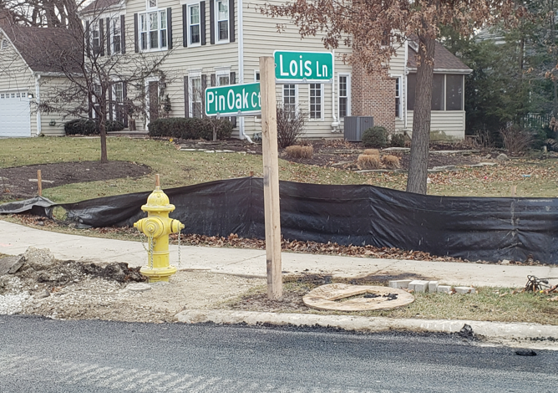

Date: April 20, 2022
To: Residents in the Pin Oak Court Area, Wheaton
From: Wheaton Sanitary District (WSD)
Subject: Northside Interceptor Sewer Replacement Project
Pin Oak Court Area Concrete Construction & Driveway Restrictions

PIN OAK COURT AREA CONCRETE CONSTRUCTION & DRIVEWAY RESTRICTIONS MEMO:
PLEASE BE INFORMED THAT CONCRETE CONSTRUCTION (CURB, GUTTER, SIDEWALK, AND EXISTING CONCRETE DRIVEWAY APRON REPLACEMENT)
WILL BE OCCURRING OVER THE NEXT WEEK OR SO IN YOUR AREA, WEATHER PERMITING. IN ORDER FOR THE CONCRETE TO PROPERLY
CURE, ALL PROPERTIES WILL NEED ALL VECHICLES TO BE OUT OF DRIVEWAYS AND GARAGES BY 7:00 AM, SATURDAY, 4/23/2022. IN THE EVENT OF RAIN ON SATURDAY, THE SCHEDULE WILL BE PUSHED AS WEATHER DICTATES. IT IS ESTIMATED THAT DRIVEWAY ACCESS WILL BE RESTORED FOUR DAYS FOLLOWING THE CONCRETE POUR. DRIVEWAYS MAY NOT BE USED IN THE INTERIM. PARKING, INCLUDING OVERNIGHT, WILL BE AVAILABLE ON ADJACENT STREETS.
Other Specifics:
● Final construction and restoration activities are expected to conclude in May 2022.
● Construction and restoration activity will be from 7:00 am - 5:00 pm, but is allowed until 7:00 pm.
● Full restoration of the area will follow as weather permits, and will include:
- Pavement removal and rough grading
- Curb, gutter, sidewalk, and driveway replacement
- Fine grading, and final pavement restoration
- Landscaping will include seed and blanket, and tree planting
● For those with asphalt driveways, you will have stone on a temporary basis, and the portion
of your driveway effected will be replaced when the street is paved.
● Driveway repair for residents with brick pavers will occur throughout the overall restoration.
● For Project updates, visit – www.wsd.dst.il.us/about-wsd/news/ or
for questions call Jim Snell (815) 444-3321.
● WSD recognizes that its Northside Interceptor (NSI) Sewer Replacement Project has been
difficult on the residents of the Pin Oak Court area, and appreciates everyone’s patience and
consideration so this very important project can be completed. Thank you!

